**COM547 - Computing Systems Project**

**Improved Student Issue Reporting and Resolution by effective communication with the Course Representative through a Website or an Application**

**The Project Plan**

**Philip Colman**

**B00653176**

**Supervisor: Dr Dewar Finlay**

**Date: October 2017**

Contents

1.0 Purpose of the project and its context Page 3

1.1 Purpose

1.2 Current System

1.3 Context

2.0 Aim and Objectives of the project Page 4-5

2.1 Project Aim

2.2 Objectives for the project

2.3 Project Scope

2.4 Stakeholders

2.5 involvement of identified stakeholders

3.0 Lifecycle to be used in the project Page 6-

3.1 What is a project lifecycle

3.2 Waterfall

3.3 Iterative

3.4 Spiral

3.5 Agile

3.6 Why it was chosen

1.0 Purpose of the project and its context

**1.1 Purpose**

The Purpose of the project is to create a dedicated website or an app for students in the university to communicate as a class with the intention of resolving issues and being more informative about issues student face than simple asking during class or posting a request for feedback on a Facebook group.

**1.2 Current System**

Are class currently uses a Facebook group chat for communicating. This is obviously very effective as Facebook maintains and update the service. The Service allows for everyone who has a Facebook account who has been added to the group to share, receive, respond, and like things that they or others have chosen to share with the group. When this happens the application notifies the other members that there has been a post in group. This is a very important feature as it allows all members of the group to remain informed of any developments.

**1.3 Context**

While the current method we are using as a group is excellent a more targeted system could allow for greater involvement and easier resolution to issues for students within the university.

Recognizing that the target audience is the students we can design specific features for that group. One example of the common behaviors of a group is that one person usually finds dates for things like first day of the semester or dates for exams and then post that information to the group or others ask when a deadline for an assignment is and someone responds.

Given awareness of this we can add a calendar to the website and/or** application, that allows people to see this information as it approaches instead of dropping of the screen when other comments are posted after this saving other people searching for it later.

One of the main reasons for this project is to improve feedback from the group and allowing the student representative to remain more up to date on issues involving the group or a member of the group with this in mind we can develop tools to help the student representative to respond better with solutions, add issues for other members to comment on, and develop reports for effective and informed feed back to the SSCC forms.

Not everyone in group has a Facebook account or wants to be added to the group by separating it from the social media experience and potentially combining it with the university account we can get around any issues they may have. We can also set up their account so they are automatically in the group with member from the same course. (Probably will be a mock up)**

**2.0 Aim and Objectives of the project.**

**2.1 Project Aim**

The aim of the project is to create a means for a class to effectively communicate information about the running of the course with each other and report any problems that they may have. These website/app should then have tools for resolving the problems and creating a report. The website/app should also allow for social communications also.

**2.2 Objectives for the project.**

1. A conversation should be created for the group to discuss the issue notifying all students in the class of the issue. This part not only allow other students to answer but also indicate they have the same issue. If the issue is resolved all individuals who had the issue should indicate the issue is resolved and the course representative should sign off on it, writing a report if necessary.
2. A one to one with the course representative, text or voice in app or on the web page with email available also.
3. Some way to communicate with the course tutors on the website or in app if necessary.
4. Some way to communicate with the course co-ordinator on the website orin app if necessary.
5. Application is secondary objective

Steps to complete objectives (needs update**)

1. Define exact features for the webpage/app
2. Research programming language (PHP vs ruby)
3. Create database for users
4. Create basic interface
5. Basic messaging system
6. Research web sockets for live chat functionality
7. Storyboard website design
8. Research Twilio or alternative integration
9. Fully documented testing process
10. Sanitise user inputs so that can mess with the database

**2.3 Project Scope**  
The Project will be able to allow user to communicate by several different means 1 to 1 chat group chat, issue reporting where a check system will indicate resolution of the issue and VOIP chat. There will be a well-designed front end to the website and a database will have user information like sign in details and history available.

Resources

The resource I have are:

* My own laptop as well as the use of desktops in the university.
* A text editor
* WAMP server
* A web browser
* A Smartphone
* Apache Cordova

**2.4 Stakeholders**

The people or groups of people who have an interest in this project would be other students as it will improve their communication with the course representative and other members of the class. The course representatives should be able to collect more useful information and have tools available to make reporting or resolving an issue easier.

**2.5 involvement of identified stakeholders**

3.0 Lifecycle to be used in the project

**3.1 What is a project lifecycle**

A software development lifecycle is used to create a product in a cost-efficient manor, at high quality within the shortest period of time. I have analyzed several different lifecycle models to determine the one most effective for my project.

**3.2 Waterfall**

The waterfall model is a Lifecycle where you complete one stage before moving on to the next, for example you would have to complete the planning stage before moving onto the design stage. It is called the waterfall model because it is generally drawn as steps going down from the first stage at the top and the last stage at the bottom. During development, you then flow down the steps from one stage onto the next like water going down a waterfall. You cannot skip any steps as each step is has tasked that are required to be completed to start the following step.

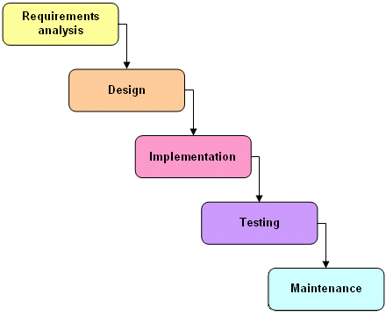

**3.2 Waterfall Continued**

**Advantages**

* Thoughtful analysis is put into the development of the project in the early stages determining what is going to be needed and what needs to be done. This allows for research to be done in the early planning stages and this can allow for identifying issues that may occur so they can be resolved before continuing.
* This model is a linear process which is easier to understand.
* This model generally gets lots of documentation as the early stages are all about the planning for the later stages.

**Disadvantages**

* Requires an upfront understanding of the entire project.
* Changes in the later stages are difficult to implement. Developers may use change control procedures to define what can be changed which still will not be easy to perform.
* Many issues will not be identified in the earlier stages, changing things later would prove difficult.
* Sample pieces cannot be put together as the project requires early stages to be completed before any attempt at implementation.

**3.3 Iterative**

The Iterative model goes through iterations or version of the software build. There is an initial planning stage which is then followed up by stages that are repeated until the software is fully developed, the project is incrementally built up over each iteration.

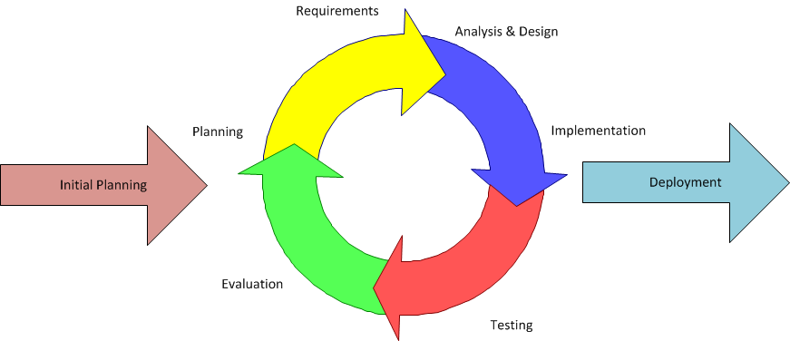

**Advantages**

* Any problems that occur can be worked out during the next iteration by the time you get to the final iteration the problems will be worked.
* Any changes that get requested can be made during the next iteration.
* Each iteration builds on the last so you do not need to fully implement the whole project on the first iteration like waterfall.

**Disadvantages**

* Requires engagement of the stakeholder the project is being designed for throughout the project as feedback will be required after every iteration.
* As a result of this continuous feedback the user may continually request new feature which can quickly lead to a runaway of scope, time and cost.

**3.4 Spiral**

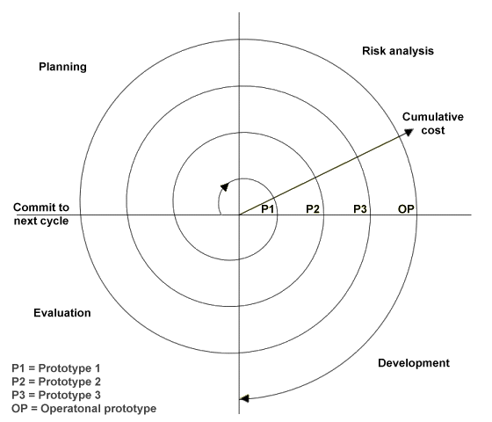The Spiral model also has an iterative approach however it puts emphases on risk analysis. The biggest difference is that the iteration is broken up into 4 key phases. Which are define objectives, Identify and resolve risk, developing the project and testing it and then planning the next iteration.

**Advantages**

* There is an emphasis on risk analysis
* Good for larger or critical projects

**Disadvantages**

* The model has larger cost involved with development as well as being more time consuming making it not practical for smaller scale projects

**3.5 Agile**

There are several kinds of agile development cycles each with slightly different ways of doing things. The general concept is that a team member will be able to take and complete an individual task from the product backlog. Completing these task is called a sprint. A scrum master watches over the development of the project to ensure that it can be put together at the end as a finished product. Given its nature it is a team exercise.

This picture needs changed others need check to make sure they are open source**

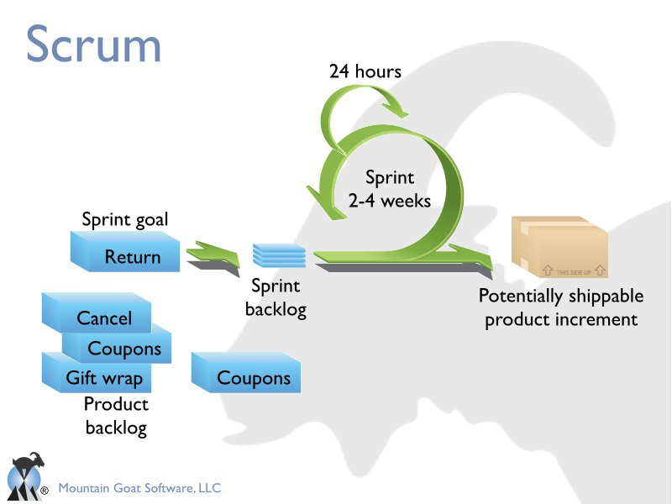

**Advantages**

* The project has a completed work product at the end of each sprint that can be interacted with allowing for changes to be made when they are needed.

**Disadvantages**

* Documentation related to the development is minimum if any as the developers can jump straight in to produce their work.
* All stake holders need to remain in constant communication.

**3.6 Why it was chosen**

10. Plan for the management of project data.

*Considerations in relation to the security and integrity of your project documentation and code.*

*GitHub + regular backup*

11. Plan for knowledge and skills needed to perform the project. *

*Think about the skills required and whether new skills are needed.*

(WBS) top-level work breakdown

1. Fully Functional Website

1.1 Research programming language (PHP vs ruby)

1.1.1 Choose a language document the decision making process

1.6 Fully documented testing process

1.6.1 Create a list of task for testing based of functionality and requirements

1.6.2 Create completed Volere templates for tasks

1.4 Messaging systems

1.4.1 Server side chat system

1.4.2.1

Research web sockets for live chat functionality and online status

1.4.2.2 Integrate Live Chat functionality

1.4.3.1

Research Twilio or alternative for VOIP

1.4.3.2 Integrate a VOIP, Text messaging and phone call system on the website/in app

1.4.2 Live Chat

1.4.3 VOIP, Text messages, Phone Calls

1.2.1 Storyboard website design

1.2.2 Storyboard app design

1.2 Website design layout

1.3.1 Implement layout plus design with HTML and CSS

1.3.4 Sanitise user inputs so that user cannot mess with the database

1.3 Develop Website/app

1.3.5 Use apache Cordova software to convert website to a web browser application

1.3.2 Use chosen language to add server side functionality to the website

1.3.3 Create a database to contain user data

1.5 Add Features

1.5.1 Public Report Issue

1.5.2 Private Report Issue

1.5.3 Generate Report for SSCC

1.6.4 Fix any problems that occur run test until all success

1.6.3 Pass/Fail

Checklist

(WBS) Table form

1. Fully Functional Website

1.1 Research programming language (PHP vs ruby)

1.1.1 Choose a language document the decision making process

1.2 Website design layout

1.2.1 Storyboard website design

1.2.2 Storyboard app design

1.3 Develop Website/app

1.3.1 Implement layout plus design with HTML and CSS

1.3.2 Use chosen language to add server side functionality to the website

1.3.3 Create a database to contain user data

1.3.4 Sanitise user inputs so that user cannot mess with the database

1.3.5 Use apache Cordova software to make convert website to a web browser application

1.4 Messaging systems

1.4.1 Server side chat

1.4.2 Live Chat

1.4.2.1 Research web sockets for live chat functionality and online status

1.4.2.2 Integrate Live Chat functionality

1.4.3 VOIP, Text messages, Phone Calls

1.4.3.1 Research Twilio or alternative for VOIP

1.4.3.2 Integrate a VOIP, Text messaging and phone call system on the website/in app

1.5 Add Features

1.5.1 Public Report Issue

1.5.2 Private Report Issue

1.5.3 Generate Report for SSCC

1.6 Fully documented testing process

1.6.1 Create a list of task for testing based of functionality and requirements

1.6.2 Create completed Volere templates for tasks

1.6.3 Pass/Fail checklist

1.6.4 Fix any problems that occur run test until all success

*Tasks in the structure should follow from the lifecycle based objectives.*

They do but renaming thing to make that clearer may be an idea**

WBS Dictionary

|  |
| --- |
| Project Title: Improved Student Issue Reporting and Resolution by effective communication with the Course Representative through a Website or an Application |
| WBS Number: 1.1 |
| WBS Item Name: Research programming language (PHP vs ruby) |
| Description: Research each language and what each can do differently. |

|  |
| --- |
| Project Title: Improved Student Issue Reporting and Resolution by effective communication with the Course Representative through a Website or an Application |
| WBS Number: 1.1.1 |
| WBS Item Name: Choose a language document the decision-making process |
| Description: way the pros and cons of each language and explain the decision I come to for which to use the choice will be used in the server side stage of the development. |

|  |
| --- |
| Project Title: Improved Student Issue Reporting and Resolution by effective communication with the Course Representative through a Website or an Application |
| WBS Number: 1.2.1 |
| WBS Item Name: Storyboard website design |
| Description: create designs for the website |

|  |
| --- |
| Project Title: Improved Student Issue Reporting and Resolution by effective communication with the Course Representative through a Website or an Application |
| WBS Number: 1.2.2 |
| WBS Item Name: Storyboard app design |
| Description: create designs for the application |

|  |
| --- |
| Project Title: Improved Student Issue Reporting and Resolution by effective communication with the Course Representative through a Website or an Application |
| WBS Number:1.3.1 |
| WBS Item Name: Implement layout plus design with HTML and CSS |
| Description: Create the website designed in 1.2.1 |

|  |
| --- |
| Project Title: Improved Student Issue Reporting and Resolution by effective communication with the Course Representative through a Website or an Application |
| WBS Number:1.3.2 |
| WBS Item Name: Use chosen language to add server side functionality to the website |
| Description: User accounts, Sessions etc |

|  |
| --- |
| Project Title: Improved Student Issue Reporting and Resolution by effective communication with the Course Representative through a Website or an Application |
| WBS Number: 1.3.3 |
| WBS Item Name: Create a database to contain user data |
| Description: Create a MySQL database that will contain data on users. |

|  |
| --- |
| Project Title: Improved Student Issue Reporting and Resolution by effective communication with the Course Representative through a Website or an Application |
| WBS Number: 1.3.4 |
| WBS Item Name: Sanitise user inputs so that user cannot mess with the database |
| Description: When reading a text field and using it in query’s for the database make sure the code is checked for anything malicious and does not run any unintended commands |

|  |
| --- |
| Project Title: Improved Student Issue Reporting and Resolution by effective communication with the Course Representative through a Website or an Application |
| WBS Number:1.3.5 |
| WBS Item Name: Use apache Cordova software to make convert website to a web browser application |
| Description: I knew about web browser applications from the mobile development module, it uses HTML, CSS and JavaScript, instead of java and xml in a native android application. These languages are the same ones used in a website so it should be possible to create an application based on the code created for the website research indicates that apache Cordova can do this. I need to implement this to get an application. |

|  |
| --- |
| Project Title: Improved Student Issue Reporting and Resolution by effective communication with the Course Representative through a Website or an Application |
| WBS Number: 1.4.1 |
| WBS Item Name: Server side chat |
| Description: A simple post on wall system for leaving messages. |

|  |
| --- |
| Project Title: Improved Student Issue Reporting and Resolution by effective communication with the Course Representative through a Website or an Application |
| WBS Number: 1.4.2 |
| WBS Item Name: Live Chat |
| Description: Identify a more involved method of communication than just post on a wall. |

|  |
| --- |
| Project Title: Improved Student Issue Reporting and Resolution by effective communication with the Course Representative through a Website or an Application |
| WBS Number: 1.4.2.1 |
| WBS Item Name: Research web sockets for live chat functionality and online status |
| Description: |

|  |
| --- |
| Project Title: Improved Student Issue Reporting and Resolution by effective communication with the Course Representative through a Website or an Application |
| WBS Number: 1.4.2.2 |
| WBS Item Name: Integrate Live Chat functionality |
| Description: Have a live chat functionality like messenger group chat on Facebook where other users can see who is online and who is typing. |

|  |
| --- |
| Project Title: Improved Student Issue Reporting and Resolution by effective communication with the Course Representative through a Website or an Application |
| WBS Number: 1.4.3 |
| WBS Item Name: VOIP, Text messages, Phone Calls |
| Description: Establish several other means for communication beyond messaging. |

|  |
| --- |
| Project Title: Improved Student Issue Reporting and Resolution by effective communication with the Course Representative through a Website or an Application |
| WBS Number: 1.4.3.1 |
| WBS Item Name: Research Twilio or alternative for VOIP |
| Description: I discovered Twilio for making phone calls or internet calls from inside a website or application. I need to identify and explain how I will get this to works in a report and find alternative services and compare them. |

|  |
| --- |
| Project Title: Improved Student Issue Reporting and Resolution by effective communication with the Course Representative through a Website or an Application |
| WBS Number: 1.4.3.2 |
| WBS Item Name: Integrate a VOIP, Text messaging and phone call system on the website/in app |
| Description: Add software to the website and the application that will allow the users to call or message each other through other methods. |

|  |
| --- |
| Project Title: Improved Student Issue Reporting and Resolution by effective communication with the Course Representative through a Website or an Application |
| WBS Number: 1.5.1 |
| WBS Item Name: Public Report Issue |
| Description: A public post of an issue giving all the other students a chance to respond with an answer. An option to sticky the post to the top of the page will be available to the course representative, the course representative will be able to add things to a calendar specific to their course. An option will exist to state if the problem has been resolved. |

|  |
| --- |
| Project Title: Improved Student Issue Reporting and Resolution by effective communication with the Course Representative through a Website or an Application |
| WBS Number: 1.5.2 |
| WBS Item Name: Private Report Issue |
| Description: If a student wants to report an issue to the student representative without posting it public. This feature will have option for allowing the student and course representative to state if the problem has been resolved. |

|  |
| --- |
| Project Title: Improved Student Issue Reporting and Resolution by effective communication with the Course Representative through a Website or an Application |
| WBS Number: 1.5.3 |
| WBS Item Name: Generate Report for SSCC |
| Description: A piece of code that will use the public and private reports to help the course representative create the Staff/Student consultative committees report |

|  |
| --- |
| Project Title: Improved Student Issue Reporting and Resolution by effective communication with the Course Representative through a Website or an Application |
| WBS Number: 1.6.1 |
| WBS Item Name: Create a list of tasks for testing based of functionality and requirements |
| Description: To make sure the website works as intended we need to test all the functionality of the website, we also need to make sure all the requirement for the project have been met. For this purpose I will create a list of things to test. |

|  |
| --- |
| Project Title: Improved Student Issue Reporting and Resolution by effective communication with the Course Representative through a Website or an Application |
| WBS Number: 1.6.2 |
| WBS Item Name: Create completed Volere templates for tasks |
| Description: Use a Volere template or something similar, to explain each test, how it is going to be performed and what purpose it has in the project. |

|  |
| --- |
| Project Title: Improved Student Issue Reporting and Resolution by effective communication with the Course Representative through a Website or an Application |
| WBS Number: 1.6.3 |
| WBS Item Name: Pass/Fail checklist |
| Description: create check list of all the tasks created in 1.6.2. for the purpose of mark of the task as a pass of fail after the test is run. |

|  |
| --- |
| Project Title: Improved Student Issue Reporting and Resolution by effective communication with the Course Representative through a Website or an Application |
| WBS Number: 1.6.4 |
| WBS Item Name: Fix any problems that occur run test until all success |
| Description: If any of the test failed correct the error and run all test again to make sure you didn’t break anything else, keep doing until a test past. |

Time Management

Initial Project Plan 30th October 2017

ePortfolio and Presentation 10th December 2017

Project Monitoring and Control Report 11th February 2018

Main Project Report week11/ semester 2

*Tasks should be scheduled in a Gantt chart.*

7.  Estimate the project’s effort for tasks.

PERT

Pessimistic time + 4x most likely time + optimistic time

6

Odm pdm

9. Identify and analyze project risks.

*This is of particular importance and students are encouraged to think about skills

|  |  |  |  |
| --- | --- | --- | --- |
| Project Title: Improved Student Issue Reporting and Resolution by effective communication with the Course Representative through a Website or an Application  Date of Authorization: 6/10/17  Project start date: 28/9/17  Project Finish date: 1/4/17 | | | |
| Milestones: | | | |
| Budget Information: We are allocating £0 as I will be using your personal devices to setup the system and there is free open source software available for use | | | |
| Project Manager: Philip Colman 07412598998 colman-p@email.ulster.ac.uk | | | |
| Project Objectives:  Software implementation  appropriate documentation  project report | | | |
| Main Project Success Criteria: | | | |
| Approach: | | | |
| Roles | | | |
| Name | Role | Position | Contact information |
| Dewar Finlay | sponsor | Supervisor | D.finlay@ulster.ac.uk |
| Philip Colman | Project Manager | Manager | Colman-p@email.ulster.ac.uk |
| Philip Colman | Team member | Programmer | Colman-p@email.ulster.ac.uk |
| Sign Off Signatures:  Philip Colman | | | |
| Comments | | | |

usage and any weaknesses therein that need to be addressed.

Commitments

** should be removed by final draft

Book reference**

References:

<https://stackify.com/what-is-sdlc/>

<https://manifesto.co.uk/agile-vs-waterfall-comparing-project-management-methodologies/>

<https://www.technologyuk.net/software-development/sad/images/waterfall_model.gif>

<https://www.technologyuk.net/software-development/sad/other-models.shtml>

<https://airbrake.io/blog/sdlc/iterative-model>

<https://www.inflectra.com/methodologies/waterfall.aspx>

<https://www.mountaingoatsoftware.com/presentations/an-introduction-to-scrum>

<https://www.scrumalliance.org/why-scrum>

<https://www.projectsmart.co.uk/work-breakdown-structure-purpose-process-pitfalls.php>

<https://auth0.com/blog/converting-your-web-app-to-mobile/>

Bibliography:

Schwalbe, Kathy. *Information Technology Project Management*. 1st ed.